270-Bscs-18 Haider Ali

Tic Tac Toe Game (One Player and Multiplayer with chatbox)

Thursday July 2

# Overview

## Game

|  |  |
| --- | --- |
|  | A Tic Tac Toe game is two player game in which their goal is to position their marks, horizontally,vertically and diagonally so that they make a continuos lines of three cells. A rival can prevent success by obstructing the finishing of the opponents' line. In our variation of the game, players set marks on aboard. |

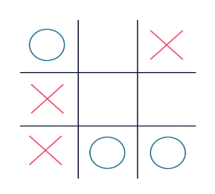

## Scope

|  |  |
| --- | --- |
|  | This particular game will have some good features and graphics. People will be able to play with computer as well as with their friends. They can also chat with ther friends while playing. You’ll get to know more about it when I’ll Launch this game. |

## Tools

|  |  |
| --- | --- |
|  | This will be done simply on Visual Studio using c# language. With a little taste of AI. |